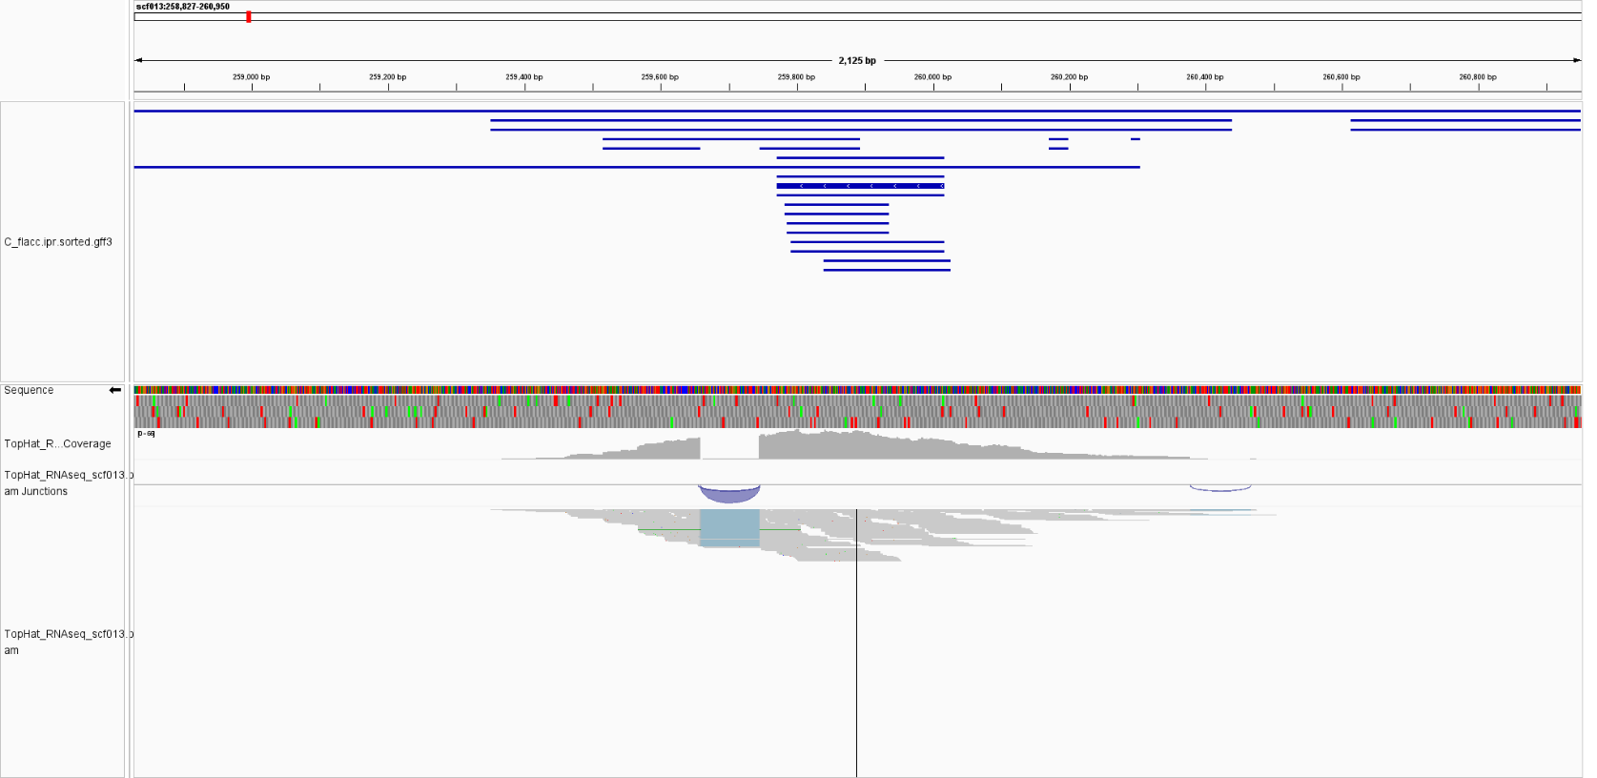

**Supplementary Fig. S1.** IGV views showing RNA‑seq coverage over first *MFA* gene in the reference genome (resting aeciospores).

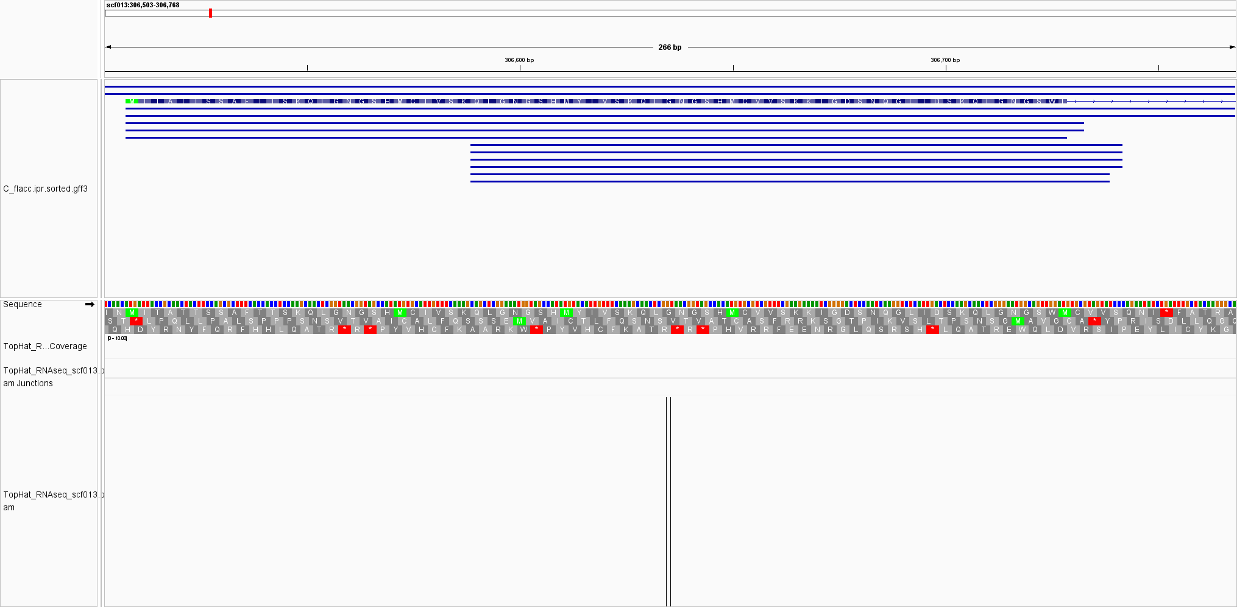

**Supplementary Fig. S2.** Lack of RNA-seq coverage at the second *MFA* gene in resting aeciospores (IGV view, reference genome).

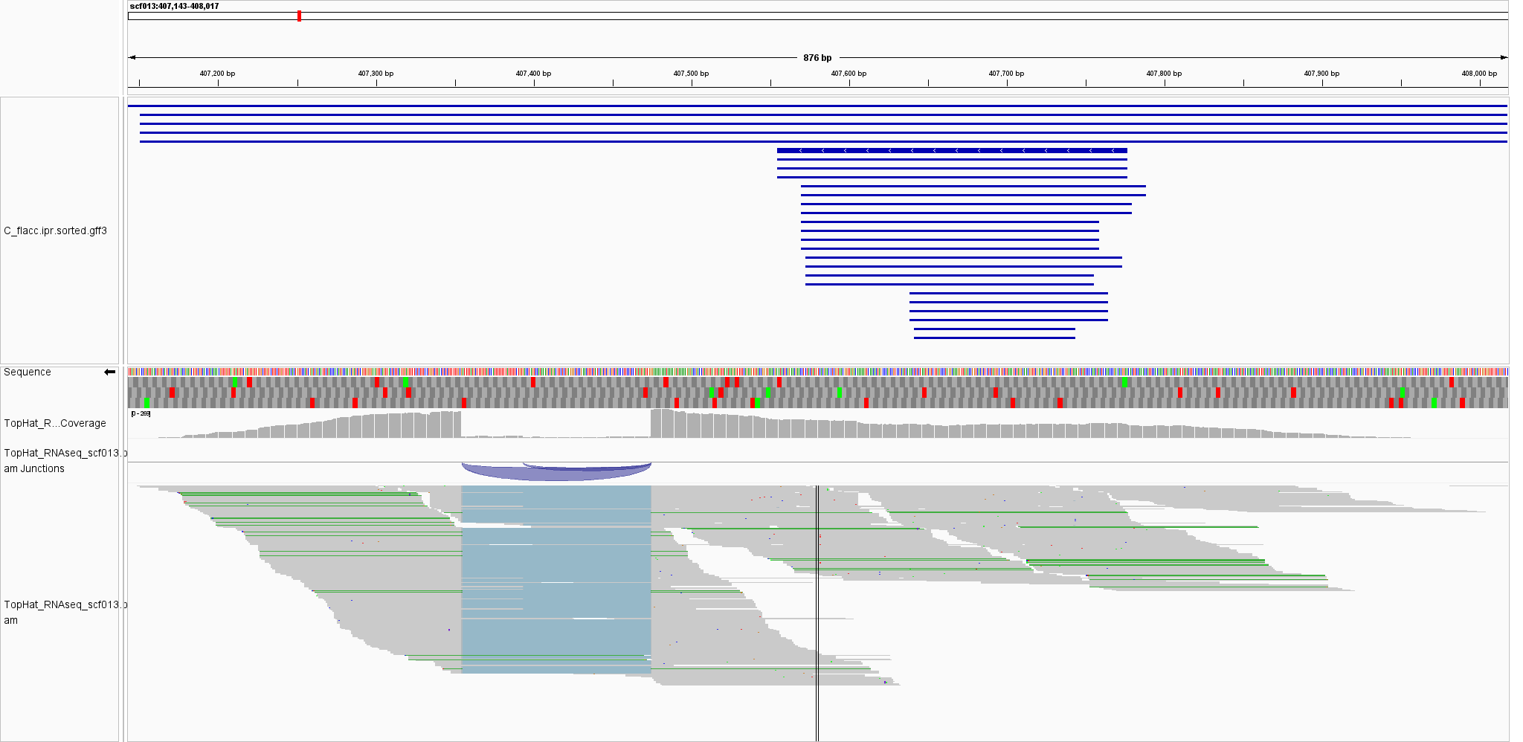

**Supplementary Fig. S3.** IGV views showing RNA‑seq coverage over third *MFA* gene in the reference genome (resting aeciospores).

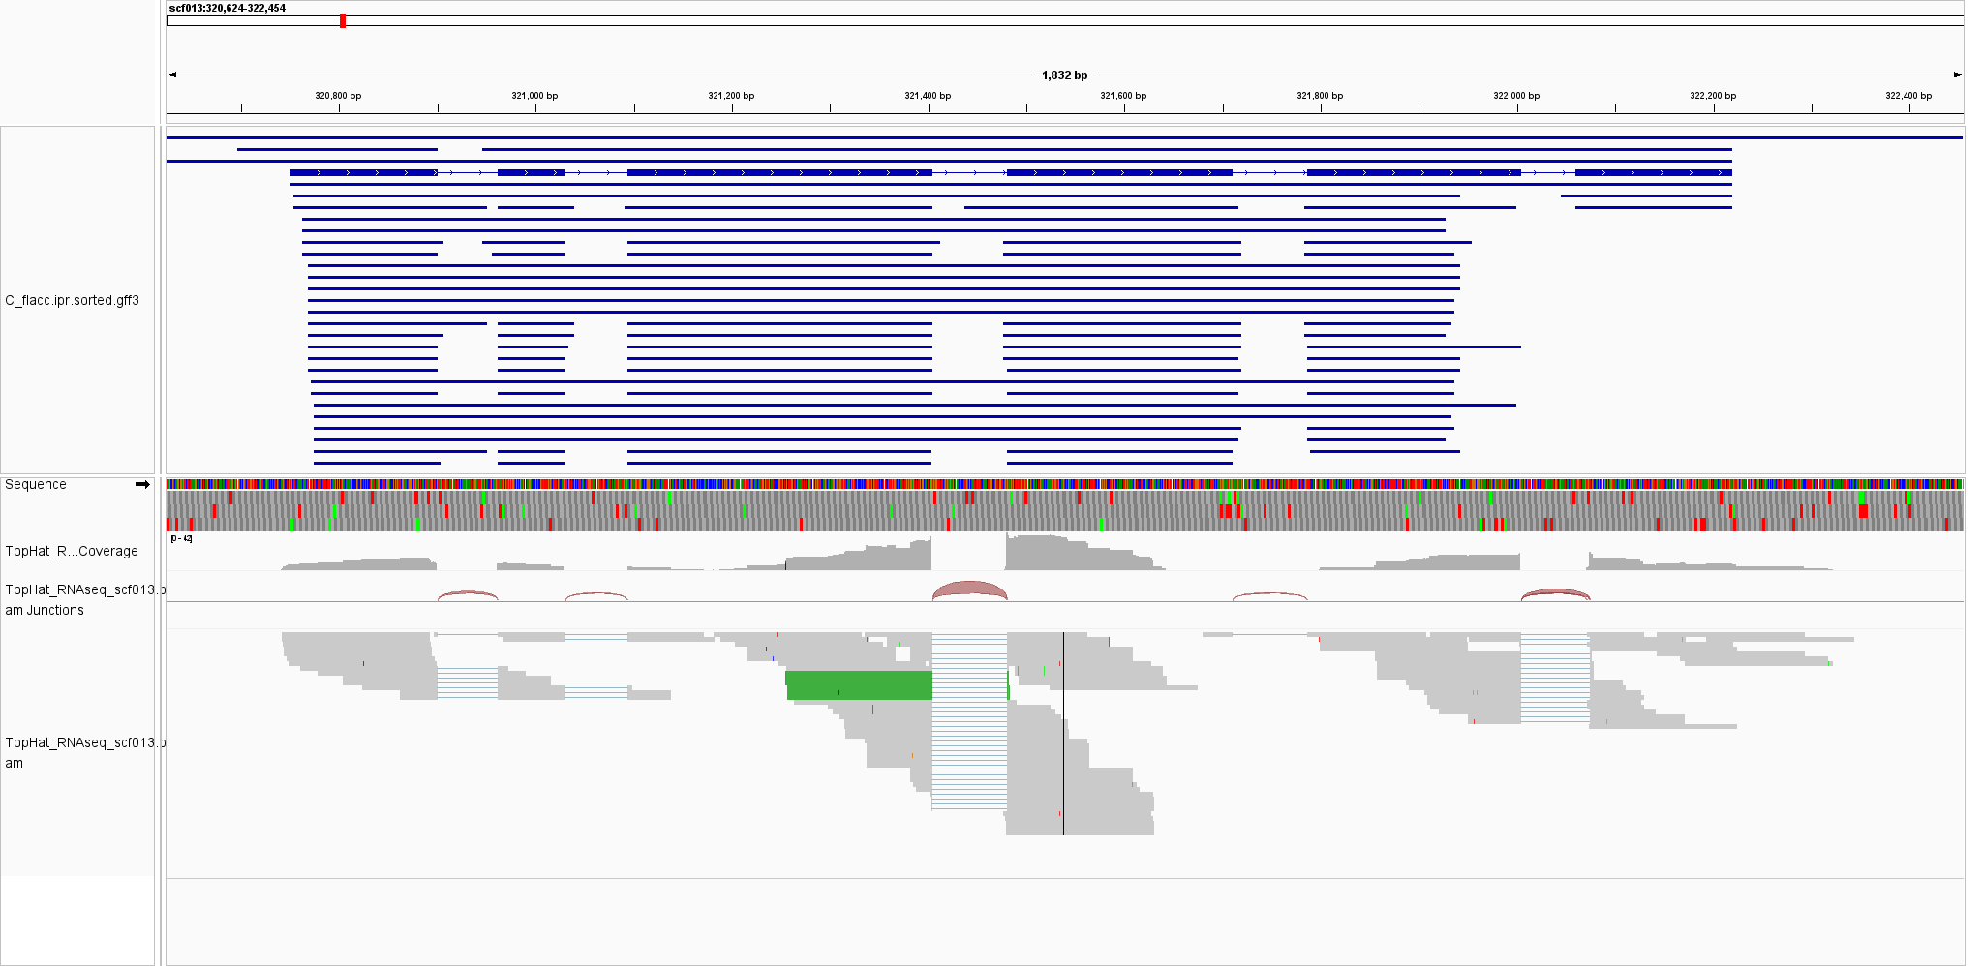

**Supplementary Fig. S4.** IGV views showing RNA‑seq coverage over *STE3.2* gene in the reference genome (resting aeciospores).

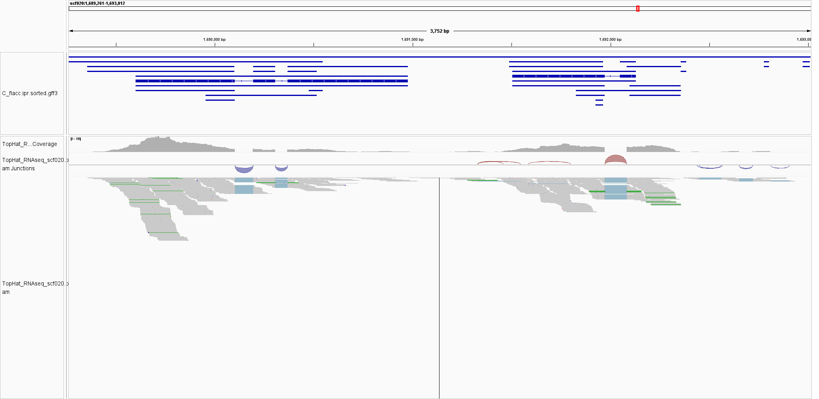

**Supplementary Fig. S5.** IGV views showing RNA‑seq coverage over second HD locus (*bW2-HD1*) in the reference genome (resting aeciospores).

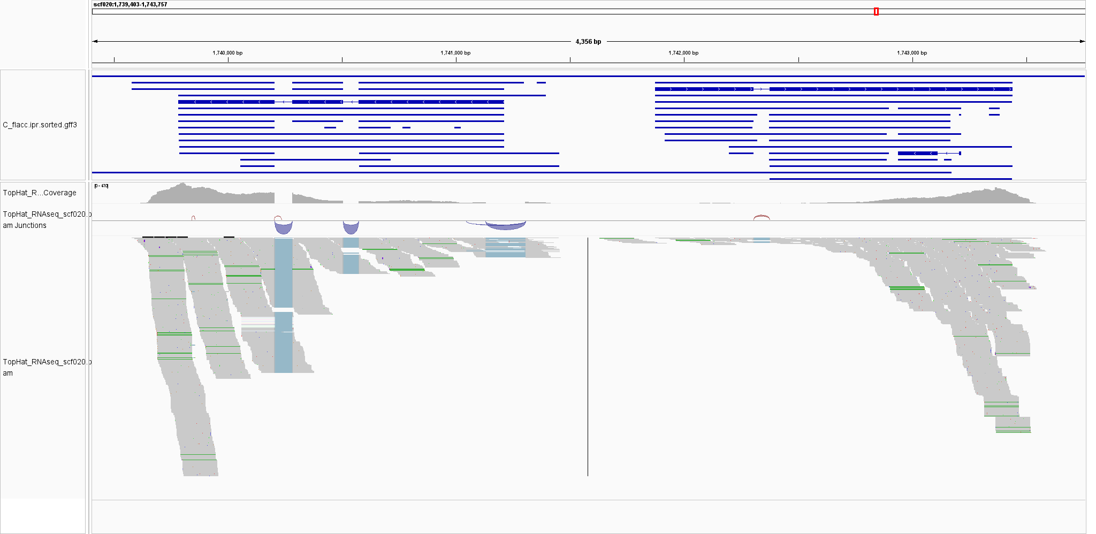

**Supplementary Fig. S6.** IGV views showing RNA‑seq coverage over first HD locus (*bW1-HD1 / bE1-HD2*) in the reference genome (resting aeciospores).

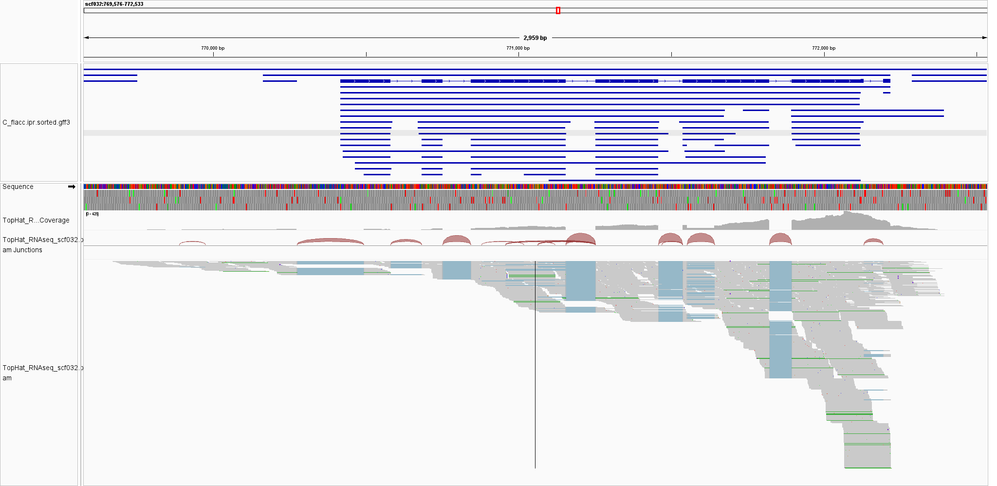

**Supplementary Fig. S7.** IGV views showing RNA‑seq coverage over *STE3.2-1* gene in the reference genome (resting aeciospores).

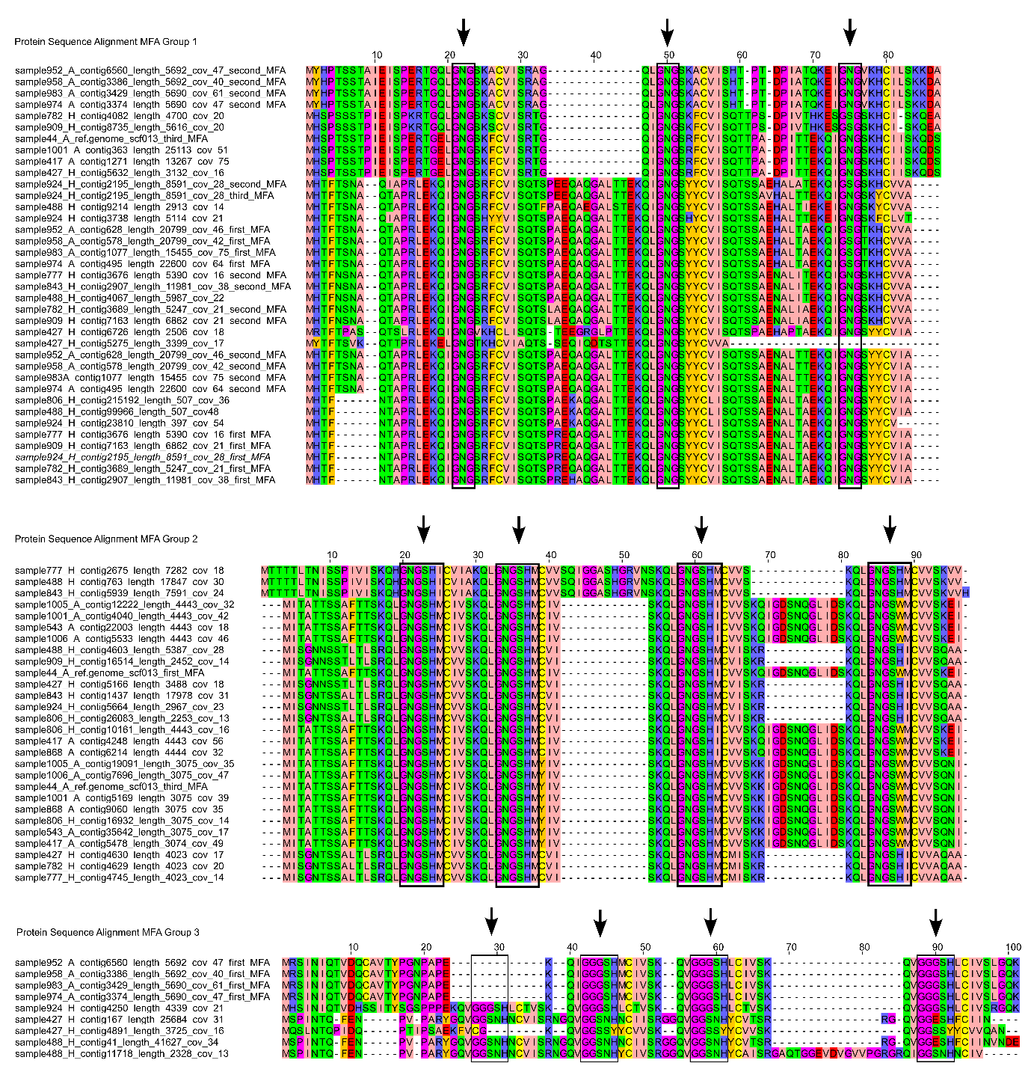

**Supplementary Fig. S8.** Tandem repeat motifs in MFA protein sequences of *Cronartium pini*. Arrows point out tandem repeats on each MFA group.

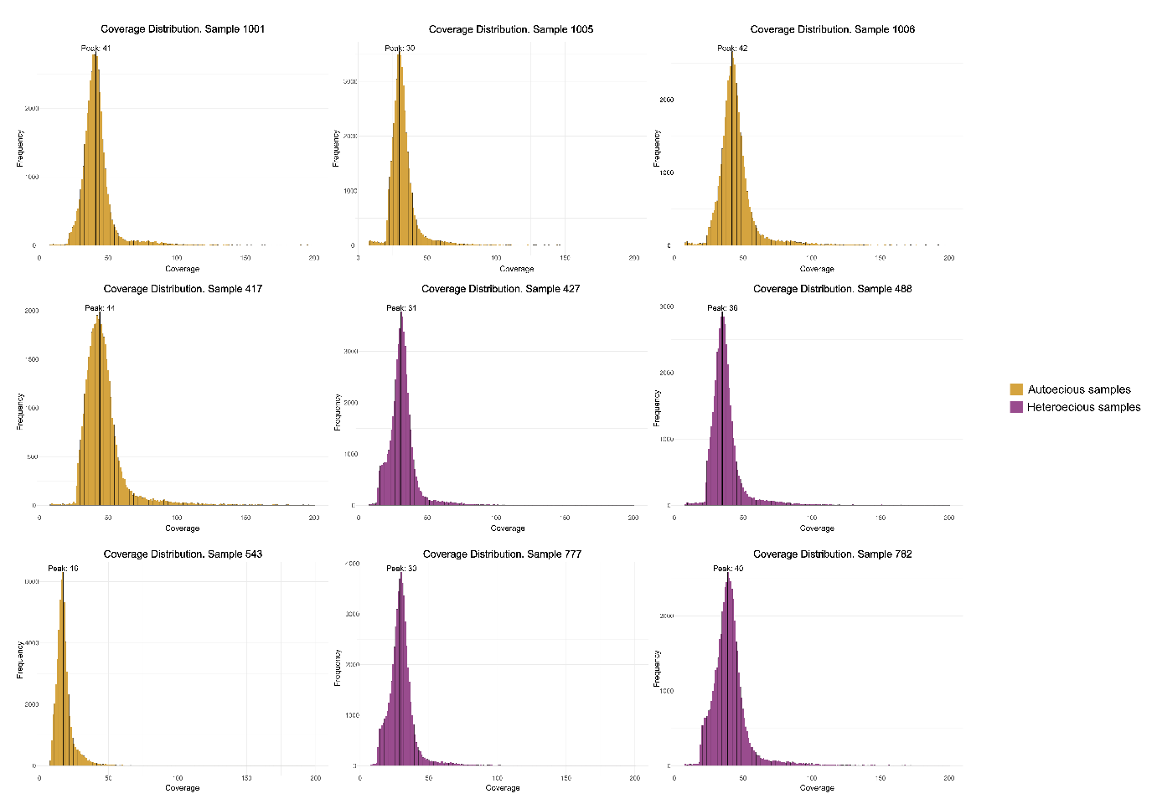

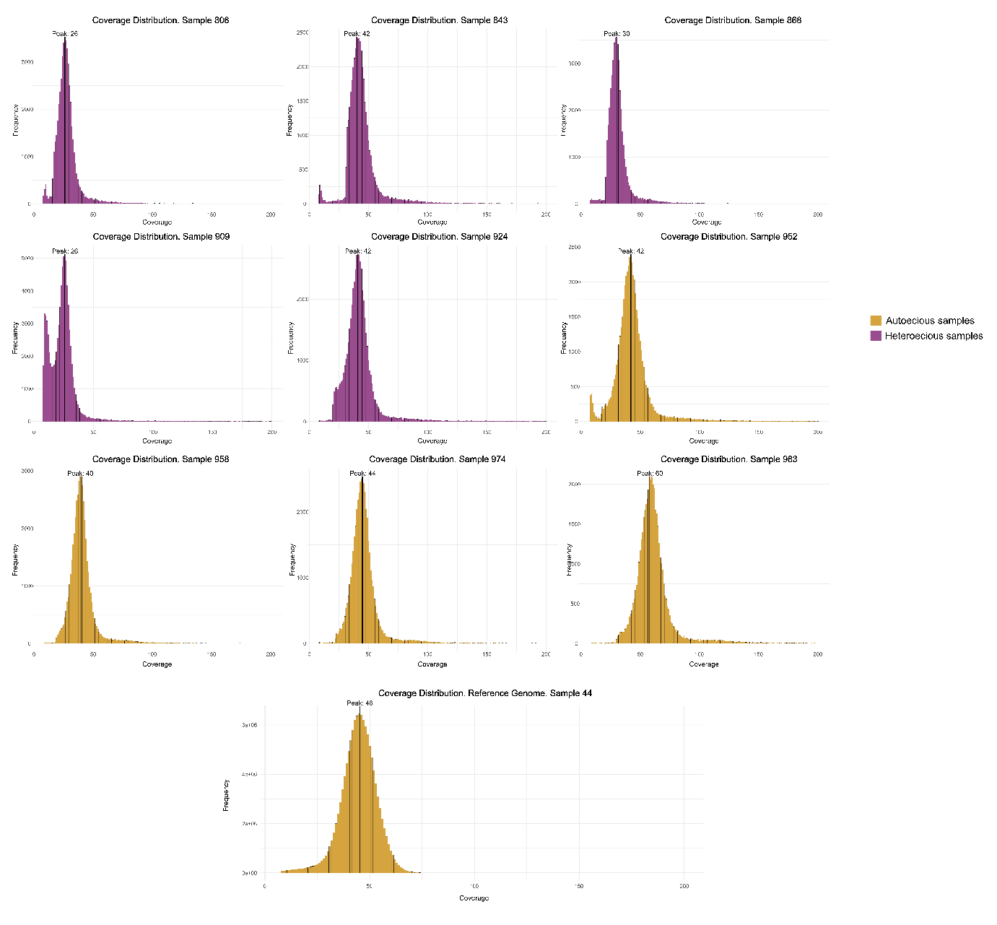

**Supplementary Fig. S9.** Coverage distributions of *de novo* genome assemblies of *Cronartium pini* forms.

|  |  |  |  |  |  |  |  |  |  |  |  |
| --- | --- | --- | --- | --- | --- | --- | --- | --- | --- | --- | --- |
| **Form** | **Sample ID** | **Genome Coverage**  **= 2 copies** | **First HD locus** | | | | | | **Second HD locus** | | |
| ***BW1-HD1*** | | | ***BE1-HD2*** | | | ***BW2-HD1*** | | |
| **Scaffold** | **Coverage (reads = proportion)** | **Copies** | **Scaffold** | **Coverage (reads = proportion)** | **Copies** | **Scaffold** | **Coverage (reads = proportion)** | **Copies** |
| Autoecious | 44* | 46 | 20 | 46 = 1.0 | 2 | 20 | 53.48 = 1.16 | 2 | 20 | 47.9 = 1.04 | 2 |
| 1001 | 41 | 188 | 40 = 0.98 | 2 | 188 | 40 = 0.98 | 2 | - | - | - |
| 1005 | 30 | 823 | 29 = 0.97 | 2 | 823 | 29 = 0.97 | 2 | - | - | - |
| 1006 | 42 | 574 | 39 = 0.93 | 2 | 574 | 39 = 0.93 | 2 | - | - | - |
| 543 | 16 | 1737 | 16 = 1.0 | 2 | 1737 | 16 = 1.0 | 2 | - | - | - |
| 417 | 44 | 449 | 43 = 0.98 | 2 | 449 | 43 = 0.98 | 2 | 34 | 48 = 0.77 | 2 |
| 868 | 30 | 673 | 28 = 0.93 | 2 | 673 | 28 = 0.93 | 2 | 153 | 31 = 1.03 | 2 |
| 952 | 42 | 540 | 38 = 0.90 | 2 | 540 | 38 = 0.90 | 2 | - | - | - |
| 958 | 40 | 513 | 37 = 0.93 | 2 | 513 | 37 = 0.93 | 2 | - | - | - |
| 983 | 60 | 186 | 60 = 1.0 | 2 | 186 | 60 = 1.0 | 2 | - | - | - |
| 974 | 44 | 484 | 41 = 0.93 | 2 | 484 | 41 = 0.93 | 2 | - | - | - |
| Heteroecious | 427 | 31 | 14424 | 18 = 0.58 | 1 | 8503 | 18 = 0.58 | 1 | 2996 | 16 = 0.52 | 1 |
| 14703 | 16 = 0.52 | 1 | 7091 | 19 = 0.61 | 1 |
| 488 | 36 | 206 | 30 = 0.83 | 2 | 206 | 30 = 0.83 | 2 | 3311 | 18 = 0.50 | 1 |
| 4428 | 10 = 0.36 | 1 | 4428 | 10 = 0.36 | 1 |
| 806 | 26 | 11187 | 13 = 0.50 | 1 | 11187 | 13 = 0.50 | 1 | 9925 | 14 = 0.54 | 1 |
| 1205 | 21 = 0.81 | 2 | 1205 | 21 = 0.81 | 2 |
| 777 | 30 | 4569 | 16 = 0.53 | 1 | 4569 | 16 = 0.53 | 1 | - | - | - |
| 4615 | 15 = 0.50 | 1 | 4615 | 15 = 0.50 | 1 |
| 782 | 40 | 4678 | 21 = 0.53 | 1 | 4678 | 21 = 0.53 | 1 | - | - | - |
| 4794 | 24 = 0.60 | 1 | 4794 | 24 = 0.60 | 1 |
| 909 | 26 | 9246 | 13 = 0.50 | 1 | 9246 | 13 = 0.50 | 1 | - | - | - |
| 7223 | 13 = 0.50 | 1 | 7223 | 13 = 0.50 | 1 |
| 924 | 42 | 4206 | 20 = 0.48 | 1 | 4206 | 20 = 0.48 | 1 | 4127 | 20 = 0.48 | 1 |
| 130 | 40 = 0.95 | 2 | 130 | 40 = 0.95 | 2 |
| 843 | 42 | 9233 | 21 = 0.50 | 1 | 9233 | 21 = 0.50 | 1 | 15476 | 19 = 0.45 | 1 |
| 1360 | 34 = 0.81 | 1 | 1360 | 34 = 0.81 | 1 |

|  |  |  |  |  |  |  |  |  |  |  |  |  |  |  |
| --- | --- | --- | --- | --- | --- | --- | --- | --- | --- | --- | --- | --- | --- | --- |
| **Form** | **Sample ID** | **Genome Coverage = 2 copies** | **Third HD locus** | | | ***STE3.2-1*** | | | **STE3.2 Homologs** | | | | | |
| ***BW3-HD1*** | | | **Group 1** | | | **Group 2** | | |
| **Scaffold** | **Coverage (reads = proportion)** | **Copies** | **Scaffold** | **Coverage (reads = proportion)** | **Copies** | **Scaffold** | **Coverage (reads = proportion)** | **Copies** | **Scaffold** | **Coverage (reads = proportion)** | **Copies** |
| Autoecious | 44* | 46 | - | - | - | 32 | 43 = 0.93 | 2 | 13 | 48.6 = 1.05 | 2 | - | - | - |
| 1001 | 41 | - | - | - | 2901 | 42 = 1.02 | 2 | 4833 | 42 = 1.0 | 2 | - | - | - |
| 1005 | 30 | - | - | - | 6935 | 29 = 0.97 | 2 | 16750 | 33 = 1.0 | 2 | - | - | - |
| 1006 | 42 | - | - | - | 3569 | 43 = 1.02 | 2 | 6975 | 44 = 1.0 | 2 | - | - | - |
| 543 | 16 | - | - | - | 11808 | 16 = 1.0 | 2 | 30973 | 18 = 1.0 | 2 | - | - | - |
| 417 | 44 | - | - | - | 2960 | 50 = 1.14 | 2 | 4846 | 75 = 1.5 | 3 | - | - | - |
| 868 | 30 | - | - | - | 3979 | 33 = 1.10 | 2 | 8102 | 36 = 1.0 | 2 | - | - | - |
| 952 | 42 | 784 | 36 =0.86 | 2 | 4751 | 42 = 1.0 | 2 | - | - | - | 7918 | 45 = 1.0 | 2 |
| 958 | 40 | 1332 | 36 = 0.90 | 2 | 392 | 42 = 1.05 | 2 | - | - | - | 3582 | 42 = 1.0 | 2 |
| 983 | 60 | 1485 | 58 = 0.97 | 2 | 2912 | 62 = 1.03 | 2 | - | - | - | 3623 | 62 = 1.0 | 2 |
| 974 | 44 | 723 | 38 = 0.86 | 2 | 2878 | 48 = 1.09 | 2 | - | - | - | 3564 | 46 = 1.0 | 2 |
| Heteroecious | 427 | 31 | 2199 | 15 = 0.48 | 1 | 2821 | 33 = 1.06 | 2 | - | - | - | - | - | - |
| 488 | 36 | - | - | - | 3405 | 36 = 1.0 | 2 | - | - | - | - | - | - |
| 806 | 26 | 4759 | 13 = 0.50 | 1 | 5719 | 30 = 1.15 | 2 | 14591 | 16 = 0.5 | 1 | - | - | - |
| 777 | 30 | - | - | - | 2806 | 32 = 1.07 | 2 | - | - | - | - | - | - |
| 782 | 40 | 1123 | 38 = 0.95 | 2 | 8499 | 41 = 1.03 | 2 | - | - | - | - | - | - |
| 909 | 26 | 4135 | 31 = 1.19 | 2 | 7077 | 28 = 1.08 | 2 | - | - | - | - | - | - |
| 924 | 42 | - | - | - | 2764 | 44 = 1.05 | 2 | - | - | - | - | - | - |
| 843 | 42 | 5560 | 20 = 0.48 | 1 | 6653 | 48 = 1.14 | 2 | - | - | - | - | - | - |

|  |  |  |  |  |  |  |  |  |  |  |  |  |  |  |
| --- | --- | --- | --- | --- | --- | --- | --- | --- | --- | --- | --- | --- | --- | --- |
| **Form** | **Sample ID** | **Genome Coverage = 2 copies** | ***STE3.2* Homologs** | | | | | | | | | | | |
| **Group 3** | | | **Group 4** | | | **Group 5** | | | **Group 6** | | |
| **Scaffold** | **Coverage (reads = proportion)** | **Copies** | **Scaffold** | **Coverage (reads = proportion)** | **Copies** | **Scaffold** | **Coverage (reads = proportion)** | **Copies** | **Scaffold** | **Coverage (reads = proportion)** | **Copies** |
| Autoecious | 44* | 46 | - | - | - | - | - | - | - | - | - | - | - | - |
| 1001 | 41 | - | - | - | - | - | - | - | - | - | - | - | - |
| 1005 | 30 | - | - | - | - | - | - | - | - | - | - | - | - |
| 1006 | 42 | - | - | - | - | - | - | - | - | - | - | - | - |
| 543 | 16 | - | - | - | - | - | - | - | - | - | - | - | - |
| 417 | 44 | - | - | - | - | - | - | - | - | - | - | - | - |
| 868 | 30 | - | - | - | - | - | - | - | - | - | - | - | - |
| 952 | 42 | - | - | - | - | - | - | - | - | - | - | - | - |
| 958 | 40 | - | - | - | - | - | - | - | - | - | - | - | - |
| 983 | 60 | - | - | - | - | - | - | - | - | - | - | - | - |
| 974 | 44 | - | - | - | - | - | - | - | - | - | - | - | - |
| Heteroecious | 427 | 31 | - | - | - | - | - | - | - | - | - | - | - | - |
| 488 | 36 | - | - | - | - | - | - | 3757 | 12 = 0.5 | 1 | - | - | - |
| 806 | 26 | - | - | - | - | - | - | - | - | - | - | - | - |
| 777 | 30 | - | - | - | - | - | - | 2692 | 16 = 0.5 | 1 | - | - | - |
| 782 | 40 | 2930 | 28 = 0.5 | 1 | - | - | - | - | - | - | 3272 | 24 = 0.5 | 1 |
| 909 | 26 | 9625 | 14 = 0.5 | 1 | - | - | - | - | - | - | 8156 | 38 = 1.5 | 3 |
| 924 | 42 | - | - | - | 4060 | 25 = 0.5 | 1 | - | - | - | - | - | - |
| 843 | 42 | - | - | - | - | - | - | 7513 | 24 = 0.5 | 1 | - | - | - |

|  |  |  |  |  |  |  |  |  |  |  |  |  |  |  |
| --- | --- | --- | --- | --- | --- | --- | --- | --- | --- | --- | --- | --- | --- | --- |
| **Form** | **Sample ID** | **Genome Coverage = 2 copies** | ***STE3.2* Homologs** | | | | | | | | | | | |
| **Group 7** | | | **Group 8** | | | **Group 9** | | | **Group 10** | | |
| **Scaffold** | **Coverage (reads = proportion)** | **Copies** | **Scaffold** | **Coverage (reads = proportion)** | **Copies** | **Scaffold** | **Coverage (reads = proportion)** | **Copies** | **Scaffold** | **Coverage (reads = proportion)** | **Copies** |
| Autoecious | 44* | 46 | - | - | - | - | - | - | - | - | - | - | - | - |
| 1001 | 41 | - | - | - | - | - | - | - | - | - | - | - | - |
| 1005 | 30 | - | - | - | - | - | - | - | - | - | - | - | - |
| 1006 | 42 | - | - | - | - | - | - | - | - | - | - | - | - |
| 543 | 16 | - | - | - | - | - | - | - | - | - | - | - | - |
| 417 | 44 | - | - | - | - | - | - | - | - | - | - | - | - |
| 868 | 30 | - | - | - | - | - | - | - | - | - | - | - | - |
| 952 | 42 | 22 | 48 = 0.88 | 2 | - | - | - | - | - | - | - | - | - |
| 958 | 40 | 77 | 40 = 1.0 | 2 | - | - | - | - | - | - | - | - | - |
| 983 | 60 | 75 | 62 = 0.97 | 2 | - | - | - | - | - | - | - | - | - |
| 974 | 44 | 85 | 45 = 0.98 | 2 | - | - | - | - | - | - | - | - | - |
| Heteroecious | 427 | 31 | - | - | - | - | - | - | 4093 | 28 = 0.90 | 2 | 2515 | 16 = 0.52 | 1 |
| 488 | 36 | - | - | - | - | - | - | - | - | - | - | - | - |
| 806 | 26 | - | - | - | - | - | - | - | - | - | - | - | - |
| 777 | 30 | - | - | - | - | - | - | - | - | - | 2808 | 15 = 0.5 | 1 |
| 782 | 40 | - | - | - | - | - | - | - | - | - | 2651 | 21 = 0.53 | 1 |
| 909 | 26 | - | - | - | - | - | - | 8806 | 26 = 1.0 | 2 | - | - | - |
| 924 | 42 | - | - | - | 4496 | 25 = 0.60 | 1 | - | - |  | - | - | - |
| 843 | 42 | - | - | - | - | - | - | 11258 | 38 = 0.90 | 2 | - | - | - |

|  |  |  |  |  |  |  |  |  |  |  |  |
| --- | --- | --- | --- | --- | --- | --- | --- | --- | --- | --- | --- |
| **Form** | **Sample ID** | **Dikaryotic Genome Coverage = 1.0** | ***STE3.2* Homologs** | | | | | | ***MFAs*** | | |
| **Group 11** | | | **Group 12** | | | ***MFA* Group 1** | | |
| **Scaffold** | **Coverage (reads = proportion)** | **Copies** | **Scaffold** | **Coverage (reads = proportion)** | **Copies** | **Scaffold** | **Coverage (reads = proportion)** | **Copies** |
| Autoecious | 44* | 46 | - | - | - | - | - | - | 13 (Second MFA) | 49.8 = 1.08 | 2 |
| 1001 | 42 | - | - | - | - | - | - | 363 | 50 = 1.19 | 2 |
| 1005 | 30 | - | - | - | - | - | - | - | - | - |
| 1006 | 42 | - | - | - | - | - | - | - | - | - |
| 543 | 16 | - | - | - | - | - | - | - | - | - |
| 417 | 42 | - | - | - | - | - | - | 1271 | 74 =1.76 | 4 |
| 868 | 30 | - | - | - | - | - | - | - | - | - |
| 952 | 42 | - | - | - | - | - | - | 628 (2x) | 45 = 1.07 | 2 |
| 6560 | 47 = 1.0 | 2 |
| 958 | 40 | - | - | - | - | - | - | 578 (2x) | 42 = 1.0 | 2 |
| 3386 | 40 = 1.0 | 2 |
| 983 | 60 | - | - | - | - | - | - | 1077 (2x) | 75 = 1.25 | 3 |
| 3429 | 60 = 1.0 | 2 |
| 974 | 44 | - | - | - | - | - | - | 495 (2x) | 64 = 1.45 | 3 |
| 3374 | 47 = 1.0 | 2 |
| Heteroecious | 427 | 31 | - | - | - | - | - | - | 6726 | 18 = 0.5 | 1 |
| 5275 | 17 = 0.5 | 1 |
| 5632 | 16 = 0.5 | 1 |
| 488 | 36 | 763 | 30 = 0.83 | 2 | 3142 | 33 = 0.92 | 2 | 99966 | 47 = 1.31 | 3 |
| 4067 | 22 = 0.61 | 1 |
| 9214 | 14 = 0.39 | 1 |
| 806 | 26 | - | - | - | 7321 | 15 = 0.58 | 1 | 215192 | 36 = 1.5 | 3 |
| 777 | 30 | 2675 | 18 = 0.60 | 1 | - | - | - | 3676 (2x) | 16 = 0.5 | 1 |
| 782 | 40 | - | - | - | - | - | - | 3689 (2x) | 21 = 0.5 | 1 |
| 4082 | 20 = 0.5 | 1 |
| 909 | 26 | - | - | - | - | - | - | 7163 (2x) | 21 = 1.0 | 2 |
| 8735 | 20 = 1.0 | 2 |
| 924 | 42 | - | - | - | 3640 | 22 = 0.52 | 1 | 23810 | 54 = 1.21 | 2 |
| 2195 (3x) | 27 = 0.64 | 1 |
| 3738 | 21 = 0.5 | 1 |
| 843 | 42 | 5939 | 24 = 0.57 | 1 | - | - | - | 2907 (2x) | 38 = 1.0 | 2 |

|  |  |  |  |  |  |  |  |  |
| --- | --- | --- | --- | --- | --- | --- | --- | --- |
| **Form** | **Sample ID** | **Dikaryotic Genome Coverage = 1.0** | ***MFAs*** | | | | | |
| ***MFA* Group 2** | | | ***MFA* Group 3** | | |
| **Scaffold** | **Coverage (reads = proportion)** | **Copies** | **Scaffold** | **Coverage (reads = proportion)** | **Copies** |
| Autoecious | 44* | 46 | 13 (First MFA) | 42.5 = 0.92 | 2 | - | - |  |
| 13 (Third MFA) | 67 = 1.46 | 3 |  |  |  |
| 1001 | 42 | 5169 | 39 = 0.93 | 2 | - | - | - |
| 4040 | 42 = 1.00 | 2 |
| 1005 | 30 | 19091 | 35 = 1.17 | 2 | - | - | - |
| 12222 | 32 = 1.07 | 2 |
| 1006 | 42 | 7696 | 47 = 1.12 | 2 | - | - | - |
| 5533 | 46 = 1.10 | 2 |
| 543 | 16 | 35642 | 17 = 1.06 | 2 | - | - | - |
| 22003 | 18 = 1.13 | 2 |
| 417 | 42 | 5478 | 48 = 1.14 | 2 | - | - | - |
| 4248 | 56 = 1.33 | 3 |
| 868 | 30 | 9060 | 34 = 1.13 | 2 | - | - | - |
| 6214 | 32 = 1.07 | 2 |
| 952 | 42 | - | - | - | 6560 | 47 = 1.12 | 2 |
| 958 | 40 | - | - | - | 3386 | 40 = 1.0 | 2 |
| 983 | 60 | - | - | - | 3429 | 60 = 1.0 | 2 |
| 974 | 44 | - | - | - | 3374 | 47 = 1.07 | 2 |
| Heteroecious | 427 | 31 | 5166 | 18 = 0.58 | 1 | 167 | 31 = 1.0 | 2 |
| 4630 | 16 = 0.52 | 1 | 4891 | 16 = 0.52 | 1 |
| 488 | 36 | 4603 | 28 = 0.78 | 2 | 41 | 34 = 0.94 | 2 |
| 763 | 30=0.83 | 2 | 11718 | 13 = 0.36 | 1 |
| 806 | 26 | 16932 | 14 = 0.58 | 1 | - | - | - |
| 10161 | 16 = 0.67 | 1 | - | - | - |
| 26083 | 13 = 0.54 | 1 | - | - | - |
| 777 | 30 | 4745 | 15 = 0.50 | 1 | - | - | - |
| 2675 | 18 = 0.60 | 1 | - | - | - |
| 782 | 40 | 4629 | 20 = 0.5 | 1 | - | - | - |
| 909 | 26 | 16514 | 14 = 0.54 | 1 | - | - | - |
| 924 | 42 | 5664 | 22 = 0.52 | 1 | 4250 | 20 = 0.48 | 1 |
| 843 | 42 | 1437 | 30 = 0.71 | 2 | - | - | - |
| 5939 | 24 = 0.5 | 1 | - | - | - |

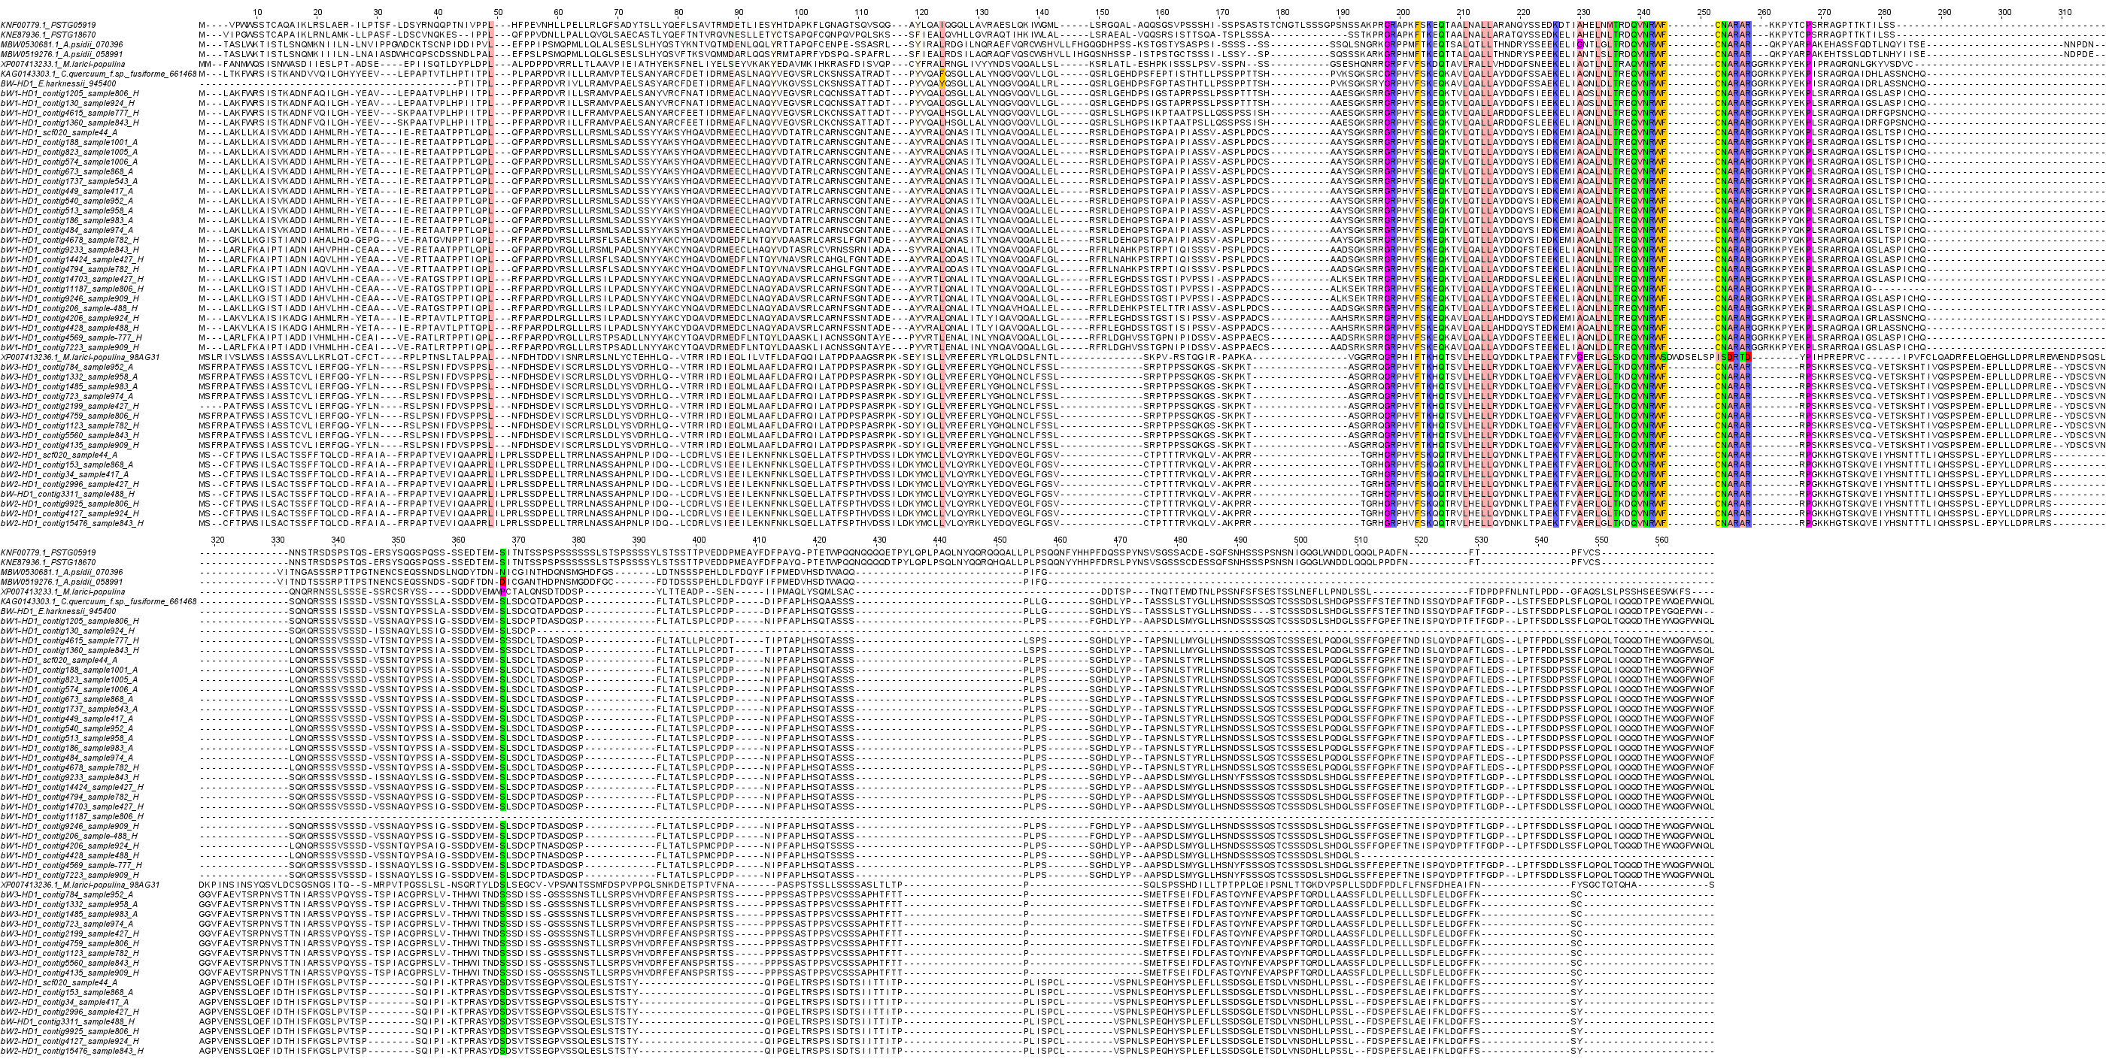

**Supplementary Fig. S10.** Alignment of bW-HD1 proteins from *Cronartium pini* and reference samples. Columns highlighted in color mark ≥90% conserved positions, including the homeodomain.

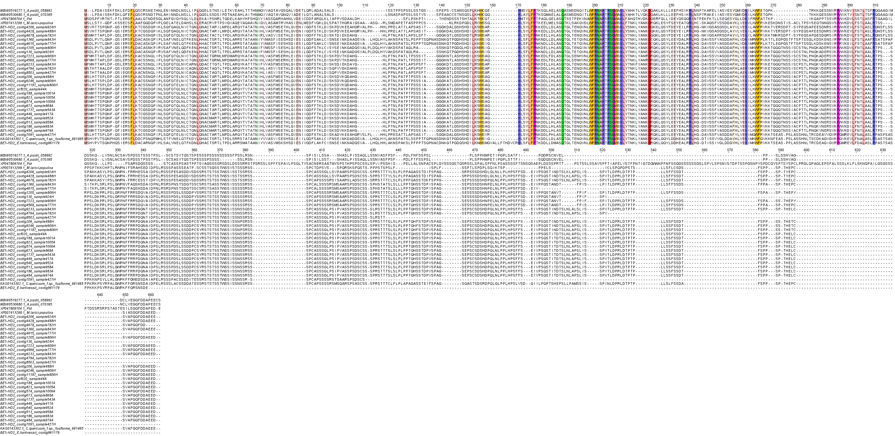

**Supplementary Fig. S11.** Alignment of *bE-HD2* proteins from *Cronartium pini* and reference samples. Columns highlighted in color mark ≥90% conserved positions, including the homeodomain.

**Supplementary Table S2.** Collected *Cronartium pini* samples.

|  |  |  |  |  |
| --- | --- | --- | --- | --- |
| **Sample ID** | **Site** | **Country** | **(Lat, Long)** | **Form** |
| 44 | Kallax | Sweden | N 65°, E 22° | Autoecious |
| 1001 | Jokela | Finland | N 60°, E 24° | Autoecious |
| 1005 | Jokkmokk | Sweden | N 66°, E 19° | Autoecious |
| 1006 | Jokkmokk | Sweden | N 66°, E 19° | Autoecious |
| 417 | Halland | Sweden | N 56°, E 13° | Autoecious |
| 427 | Gotland island | Sweden | N 57°, E 18° | Heteroecious |
| 488 | Gotland island | Sweden | N 57°, E 18° | Heteroecious |
| 543 | Halland | Sweden | N 56°, E 13° | Autoecious |
| 777 | Ätnarova | Sweden | N 67°, E 21° | Heteroecious |
| 782 | Ätnarova | Sweden | N 67°, E 21° | Heteroecious |
| 806 | Ätnarova | Sweden | N 67°, E 21° | Heteroecious |
| 843 | Övertorneå | Sweden | N 66°, E 23° | Heteroecious |
| 868 | Kallax | Sweden | N 65°, E 22° | Autoecious |
| 909 | Kolari | Finland | N 67°, E 24° | Heteroecious |
| 924 | Kolari | Finland | N 67°, E 24° | Heteroecious |
| 952 | Pudasjärvi | Finland | N 65°, E 27° | Autoecious |
| 958 | Pudasjärvi | Finland | N 65°, E 27° | Autoecious |
| 974 | Pudasjärvi | Finland | N 65°, E 27° | Autoecious |
| 983 | Pudasjärvi | Finland | N 65°, E 27° | Autoecious |

|  |  |  |  |  |  |
| --- | --- | --- | --- | --- | --- |
| **Form** | **Sample ID** | **First HD locus** | | **Second HD locus** | **Third HD locus** |
| ***BW1-HD1*** | ***BE1-HD2*** | ***BW2-HD1*** | ***BW3-HD1*** |
| Autoecious | 44 | ERZ26867828 | OZ259645 | OZ259767 | - |
| 1001 | ERZ26867829 | OZ259647 | - | - |
| 1005 | ERZ26867830 | OZ259616 | - | - |
| 1006 | ERZ26867831 | OZ259657 | - | - |
| 543 | ERZ26867832 | OZ259627 | - | - |
| 417 | OZ259535 | OZ259613 | OZ259668 | - |
| 868 | OZ259531 | OZ259649 | OZ259648 | - |
| 952 | OZ259526 | OZ259626 | - | OZ259806 |
| 958 | OZ259527 | OZ259655 | - | OZ259807 |
| 983 | OZ259534 | OZ259628 | - | OZ259861 |
| 974 | OZ259532 | OZ259660 | - | OZ259809 |
| Heteroecious | 427 | OZ259540 | OZ259656 | OZ259805 | OZ259761 |
| OZ259486 | OZ259618 |
| 488 | OZ259538 | OZ259665 | OZ259866 | - |
|  |  |  | - |
| 806 | OZ259537 | OZ259658 | OZ259670 | OZ259864 |
| OZ259539 | OZ259642 |
| 777 | OZ259542 | OZ259611 | - | - |
| OZ259543 | OZ259622 |
| 782 | OZ259528 | OZ259631 | - | OZ259862 |
| OZ259544 | OZ259663 |
| 909 | OZ259545 | OZ259617 | - | OZ259810 |
| OZ259547 | OZ259650 |
| 924 | OZ259282 | OZ259621 | OZ259868 | - |
| OZ259541 | OZ259646 |
| 843 | OZ259525 | OZ259651 | OZ259669 | OZ259863 |
| OZ259546 | OZ259615 |

|  |  |  |  |  |  |  |  |  |  |  |  |  |  |  |
| --- | --- | --- | --- | --- | --- | --- | --- | --- | --- | --- | --- | --- | --- | --- |
| **Form** | **Sample ID** | ***STE3.2-1*** | ***STE3.2* Homologs** | | | | | | | | | | | |
| **Group 1** | **Group 2** | **Group 3** | **Group 4** | **Group 5** | **Group 6** | **Group 7** | **Group 8** | **Group 9** | **Group 10** | **Group 11** | **Group 12** |
| Autoecious | 44* | OZ259757 | OZ259640 | - | - | - | - | - | - | - | - | - | - | - |
| 1001 | OZ259750 | OZ259607 | - | - | - | - | - | - | - | - | - | - | - |
| 1005 | OZ259867 | OZ259633 | - | - | - | - | - | - | - | - | - | - | - |
| 1006 | OZ259758 | OZ259608 | - | - | - | - | - | - | - | - | - | - | - |
| 543 | OZ259860 | OZ259666 | - | - | - | - | - | - | - | - | - | - | - |
| 417 | OZ259865 | OZ259644 | - | - | - | - | - | - | - | - | - | - | - |
| 868 | OZ259760 | OZ259619 | - | - | - | - | - | - | - | - | - | - | - |
| 952 | OZ259752 | - | OZ259612 | - | - | - | - | OZ259632 | - | - | - | - | - |
| 958 | OZ259759 | - | OZ259652 | - | - | - | - | OZ259659 | - | - | - | - | - |
| 983 | OZ259764 | - | OZ259629 | - | - | - | - | OZ259667 | - | - | - | - | - |
| 974 | OZ259763 | - | OZ259653 | - | - | - | - | OZ259639 | - | - | - | - | - |
| Heteroecious | 427 | OZ259751 | - | - | - | - | - | - | - | - | OZ259662 | OZ259634 | - | - |
| 488 | OZ259808 | - | - | - | - | OZ259643 | - | - | - | - | - | OZ259606 | OZ259625 |
| 806 | OZ259753 | OZ259638 | - | - | - | - | - | - | - | - | - | - | OZ259664 |
| 777 | OZ259814 | - | - | - | - | OZ259610 | - | - | - | - | OZ259635 | OZ259637 | - |
| 782 | OZ259859 | - | - | OZ259578 | - | - | OZ259624 | - | - | - | OZ259636 | - | - |
| 909 | OZ259765 | - | - | OZ259605 | - | - | OZ259620 | - | - | OZ259630 | - | - | - |
| 924 | OZ259766 | - | - | - | OZ259661 | - | - | - | OZ259641 | - | - | - | OZ259609 |
| 843 | OZ259762 | - | - | - | - | OZ259654 | - | - | - | OZ259614 | - | OZ259623 | - |

|  |  |  |  |  |
| --- | --- | --- | --- | --- |
| **Form** | **Sample ID** | ***MFAs*** | | |
| ***MFA* Group 1** | ***MFA* Group 2** | ***MFA* Group 3** |
| Autoecious | 44* | OZ260002 | OZ259987 | - |
| OZ260045 |  |
| 1001 | OZ260029 | OZ260025 | - |
| OZ260051 |
| 1005 | - | OZ259984 | - |
| OZ259979 |
| 1006 | - | OZ259982 | - |
| OZ260030 |
| 543 | - | OZ260024 | - |
| OZ259986 |
| 417 | OZ260042 | OZ260027 | - |
| OZ260047 |
| 868 | - | OZ260010 | - |
| OZ259994 |
| 952 | OZ260008 / OZ260038 | - | OZ260021 |
| OZ260004 |
| 958 | OZ259992 / OZ260001 | - | OZ260033 |
| OZ259998 |
| 983 | OZ260005 / OZ260020 | - | OZ260039 |
| OZ260041 |
| 974 | OZ260015 / OZ260016 | - | OZ260034 |
| OZ259997 |
| Heteroecious | 427 | OZ259989 | OZ259980 | OZ260014 |
| OZ259996 | OZ260035 | OZ259990 |
| OZ260013 |
| 488 | OZ260019 | OZ260048 | OZ259988 |
| OZ259995 | OZ259993 | OZ260036 |
| OZ260037 |
| 806 | OZ260043 | OZ260031 | - |
| OZ259978 |
| OZ260040 |
| 777 | OZ260028 / OZ260000 | OZ260023 | - |
| OZ260049 |
| 782 | OZ260007 / OZ259999 | OZ260011 | - |
| OZ260050 |
| 909 | OZ259991 / OZ260044 | OZ260003 | - |
| OZ260012 |
| 924 | OZ260017 | OZ260026 | OZ260032 |
| OZ259985 / OZ260046 / OZ260009 |
| OZ260018 |
| 843 | OZ260006 / OZ260022 | OZ259981 | - |
| OZ259983 |

| **Species** | **Gene name** | **ID in phylogenetic tree** | **Protein ID** | **Reference** |
| --- | --- | --- | --- | --- |
| *Austropuccinia psidii* | *bW-HD1* | *A. psidii* 070396 / *A. psidii* 058991 | MBW0530681.1 / MBW0519276.1 | Ferrarezi et al., 2022 |
| *bE-HD2* | *A. psidii* 070395 / *A. psidii* 058992 | MBW0530680.1 / MBW0519277.1 |
| *Cronartium harknessii* | *bW-HD1* | *C. harknessii* 945400 / *C. harknessii* 113817 | Endocronartium_harknessii_PhW48OC_contig945400 Endocronartium_harknessii_PhW48OC_contig113817 | Feau et al., 2018 |
| *bE-HD2* | *C. harknessii* 961179 | Endocronartium_harknessii_PhW48OC_contig961179 |
| *Cronartium quercuum f.sp. fusiforme* | *bW-HD1* | *C. quercuum* f.sp. *fusiforme* 661468 | KAG0143303.1 | Pendleton et al., 2014 |
| *bE-HD2* | *C. quercuum* f.sp. *fusiforme* 661465 | KAG0143302.1 |
| *STE3.2-1* | *C. quercuum* f.sp. *fusiforme*KAG0143345 | KAG0143345.1 |
| *STE3.2* | *C. quercuum* f.sp. *fusiforme*KAG0139918 / KAG0139804 | KAG0139918.1 / KAG0139804.1 |
| *Melampsora larici-populina* | *bW-HD1* | *M. larici-populina* XP_007413233 / *M. larici-populina* XP_007413236 | XP_007413233.1 / XP_007413236.1 | Duplessis et al., 2011 |
| *bE-HD2* | *M. larici-populina* XP_007413298 | XP_007413298.1 |
| *STE3.2-1* | *M. larici-populina* XP_007405301 | XP_007405301.1 |
| *STE3.2-2* | *M. larici-populina* MlpSTE3.2 | XP_007418099.1 |
| *STE3.2-3* | *M. larici-populina* MlpSTE3.3 | XP_007418988.1 |
| *STE3.2-4* | *M. larici-populina* MlpSTE3.4 | XP_007419438.1 |
| *MFA1* | *M. larici-populina* MlPh1 | XP_007419440.1 |
| *MFA2* | *M.* *larici-populina* MlPh2 | XP_007418113.1 |
| *MFA3* | *M. larici-populina* MlPh3 | XP_007418989.1 |
| *MFA4* | *M.* *larici-populina* MlPh4 | XP_007418445.1 |
| *MFA6* | *M*. *larici-populina* MlPh6 | XP_007418442.1 |
| *MFA8* | *M. larici-populina* MlPh8 | XP_007414982.1 |
| *MFA10* | *M*. *larici-populina* MlPh10 | XP_007415088.1 |
| *Puccinia graminis* f. sp. *tritici* | *STE3.2-1* | *P. graminis* f.sp. *tritici* PGTG00333 | XP_003307383.2 | NCBI & Cuomo et al., 2017 |
| *STE3.2-2* | *P. graminis* f.sp. *tritici* PGTG19559 | XP_003338083.1 |
| *STE3.2-3* | *P. graminis* f.sp. *tritici* PGTG01392 | XP_003319218.2 |
| *MFA1* | *P. graminis* f.sp. *tritici* MFA1 | PgtSCCL-MFA1 |
| *MFA2* | *P. graminis* f.sp. *tritici* PgtSCCL MFA2 | PgtSCCL-MFA2 |
| *MFA3* | *P. graminis* f.sp. *tritici* MFA3 | PgtSCCL-MFA3 |
| *Puccinia triticina* | *STE3.2-1* | *P. triticina* PTTG28830 | OAV89066.1 | NCBI & Cuomo et al., 2017 |
| *STE3.2-2* | *P. triticina* PTTG09751 | OAV87231.1 |
| *STE3.2-3* | *P. triticina* PTTG09693 | OAV88334.1 |
| *MFA1.3* | *P. triticina* MFA1.3 | PtBBBD_ Pt-MFA1.3 |
| *MFA2* | *P. triticina* PtBBBD MFA2 | PtBBBD_ Pt-MFA2 |
| *Puccinia striiformis* f. sp.*tritici* | *bW-HD1* | *P. striiformis* f. sp. *tritici* PSTG05919 / *P. striiformis* f. sp. *tritici* PSTG18670 | KNF00779.1 / KNE87936.1 | NCBI & Cuomo et al., 2017 |
| *bE-HD2* | *P. striiformis* f. sp. *tritici* PSTG19315 | KNE87304.1 |
| *STE3.2-1* | *P. striiformis* f. sp. *tritici* PSTG02613 | KNF04269.1 |
| *STE3.2-2* | *P. striiformis* f. sp. *tritici* PSTG15127 | KNE91469.1 |
| *STE3.2-3* | *P. striiformis* f. sp. *tritici* PSTG15070 | KNE91511.1 |
| *MFA1* | *P. striiformis* f. sp. *tritici* MFA1 | XP_047804355.1 |
| *MFA2* | *P. striiformis* f. sp. *tritici* Pst134EMFA2 | AAD56044.1 |
| *Ustilago hordei* | *PRA1* | *U. hordei* PRA1 | CAJ41875.1 | Bakkeren et al., 2006 |
| *PRA2* | *U. hordei* PRA2 | AAD56044.1 | Anderson et al., 1999 |
| **References:** | | | | |
| Anderson, C. M., Willits, D. A., Kosted, P. J., Ford, E. J., Martinez-Espinoza, A. D., & Sherwood, J. E. (1999). Molecular analysis of the pheromone and pheromone receptor genes of Ustilago hordei. Gene, 240(1), 89-97. | | | | |
| Bakkeren, G., Jiang, G., Warren, R. L., Butterfield, Y., Shin, H., Chiu, R., ... & Kronstad, J. W. (2006). Mating factor linkage and genome evolution in basidiomycetous pathogens of cereals. Fungal Genetics and Biology, 43(9), 655-666. | | | | |
| Cuomo, C. A., Bakkeren, G., Khalil, H. B., Panwar, V., Joly, D., Linning, R., ... & Fellers, J. P. (2017). Comparative analysis highlights variable genome content of wheat rusts and divergence of the mating loci. *G3: Genes, Genomes, Genetics*, *7*(2), 361-376. | | | | |
| Duplessis, S., Cuomo, C. A., Lin, Y. C., Aerts, A., Tisserant, E., Veneault-Fourrey, C., ... & Martin, F. (2011). Obligate biotrophy features unraveled by the genomic analysis of rust fungi. Proceedings of the National Academy of Sciences, 108(22), 9166-9171. | | | | |
| Feau, N., Beauseigle, S., Bergeron, M. J., Bilodeau, G. J., Birol, I., Cervantes-Arango, S., ... & Hamelin, R. C. (2018). Genome-Enhanced Detection and Identification (GEDI) of plant pathogens. PeerJ, 6, e4392. | | | | |
| Ferrarezi, J. A., McTaggart, A. R., Tobias, P. A., Hayashibara, C. A., Degnan, R. M., Shuey, L. S., ... & Quecine, M. C. (2022). Austropuccinia psidii uses tetrapolar mating and produces meiotic spores in older infections on Eucalyptus grandis. Fungal Genetics and Biology, 160, 103692. | | | | |
| Pendleton AL, Smith KE, Feau N, Martin FM, Grigoriev IV, Hamelin R, Nelson CD, Burleigh JG, Davis JM. Duplications and losses in gene families of rust pathogens highlight putative effectors. Front Plant Sci. 2014;5():299. doi: 10.3389/fpls.2014.00299 | | | | |
|  |